Name:___________________________ Date:_______________
Nurses today and in the Victorian times
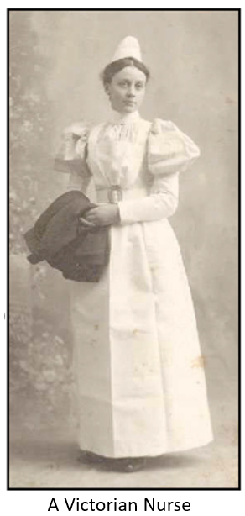
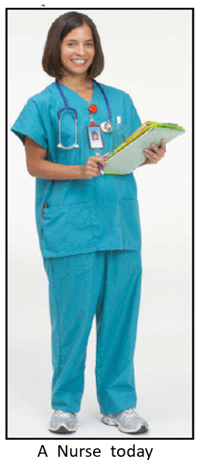
Can I identify things which are the same and things which are different from the two pictures?

Same | Different

